UMPIRES AND SCORERS TRAINING 2019-20

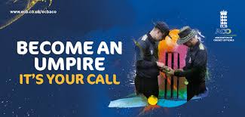

IT’S YOUR CALL - STAGE 1
This is designed to give you an overview of the basic Laws of the game and how to apply them and introduce the principles of field craft and match management. It will give you the tools to enable you to umpire matches at the basic recreational level where there are no independent umpires appointed.

Where: Edwinstowe Cricket Club
When: Sunday 10th, 17th & 24th November 2019
Times: 9:30 - 12:00pm
To Book click here.

Where: Trent Bridge Cricket Ground (Radcliffe Road Stand)
When: Sun 19th & 26th January, 2nd February 2020
Times: 9.30am – 12.30pm
To Book click here

COST
Course Fees are £30, which includes a Resource pack & first year membership of ECB ACO (membership is optional and subject to meeting application criteria). You will also receive a £20 discount code to apply for Stage Two on registration.

IT'S YOUR CALL - STAGE 2

This course is designed to build on Umpire Education Stage One, covering further Laws and exploring the concept of working as part of a team with a colleague and the scorers. It is intended to introduce you to the skills and knowledge required to be a member of a league panel. Once you have completed the course, we recommend that you refresh your understanding of the Laws covered and study them more thoroughly by referring to the MCC on-line Laws resource.

Where: Edwinstowe Cricket Club
When: Sunday 1st, 8th & 15th March 2020
Times: 9.30am – 12.00pm
To Book click here

Where: Trent Bridge Cricket Ground (Radcliffe Road Stand)
When: Sunday 1st & 15th March 2020
Times: 9.30am – 4.30pm
To book click here

COST
£30 per course, cost of this course will be reduced to £10 when discount code provided on Stage One Registration is entered at the checkout

SCORING COURSES

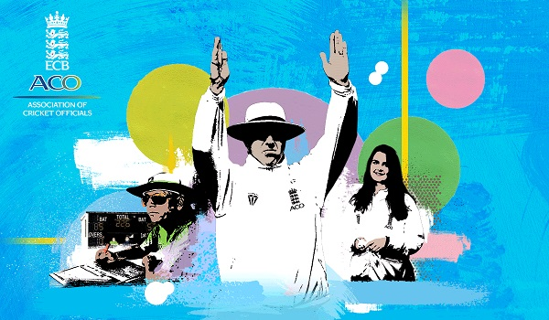

INTRODUCTION TO SCORING COURSES
The aim of this course is to provide you with the basic skills and knowledge to record a cricket match. It won’t teach you everything you need to know, but it will give you the tools and confidence to get started. Topics covered include: completing a scoring record, recognising umpire's signals, standard scoring symbols.
The course costs £30 with the price including a backpack, workbook and the assessment at the end of the relevant award.
The course is free to under 18s in full-time education and includes the opportunity to apply or renew a DBS accreditation, which is essential for all scorers.

BASIC SCORING - Complete the score-book with confidence!
This first step on the Scorers pathway is a free entry level book scoring course for everyone, including beginners and kids*. You will cover topics such as the score-sheet, signals, dismissals and scoring symbols. By completing this course you will increase your confidence to score at club level so why not sign up here today and give it a try!
* Registration for those under 16 must be with parental permission

CLUB SCORER – How to record a cricket match
Club Scorer is the course for anyone wanting to score on a regular basis and is the only one to comprehensively teach you how to score. This course is suitable for complete beginners and existing scorers who want to improve their skills. On completion of the course you’ll receive an ECB ACO club scorer certificate.
Course Details
Venue: Trent Bridge
Date: Sun 26th January 2020 - 16th February 2020
Time: 10:00am - 1pm, registration from 9:30 am on the first morning.
To Book complete our online form.

If you’d like to progress past club scorer on the pathway, you will need to become an official member of ECB ACO.

For more details on any of the courses please contact the course tutor Anne Cusworth 0115 953 9478

